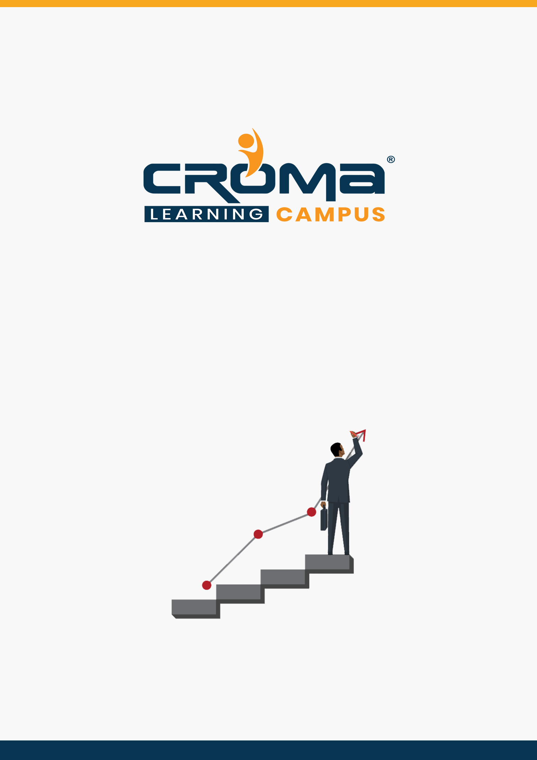

**SAP ISU Device Management Training Curriculum**

**STRUCTURE**

**www.cromacampus.com | helpdesk@cromacampus.com | +91-120-4155255**

**SAP ISU Device Management Training Curriculum**

*“Master the SAP ISU Device Management fundamentals and start a never-ending career in the SAP space right away with us!”*

**Course Objectives:**

* Understand the main Device Management processes.
* Understand the scope of device management based on SAP ISU
* Configure the processes related to Device Management
* Understand how Business Rules Framework is embedded into Device Management and what it can be used for?
* Configure Business Rules Framework for Device Management.
* Describe how ISU/CCS is integrated with standard SAP.

**Course Description:**

ISU/CCS Device management includes device technology, Device Installation, Meter reading and Inspection and certification of device. Device category/device is essentially identical to the material/equipment; hence all of the data and functions of the standard Logistics component are linked to Device Management module of ISU.

* Inventory Management
* Purchasing
* Warehouse management
* Plant maintenance
* Classification system

In the IS-U Device Management component, we can use IS-U-specific data and functions over and beyond the functions available in the R/3 Logistics application component. These include the following data and functions: ­

* Technical data, such as register group, input/output group, and command group
* Installation as well as removal and replacement of devices in an installation
* Installation Structure for representing device and register relationships, and the rate data of these devices
* Organization and execution of meter readings in the supply area
* Device inspection: sampling procedure, certification, and periodic replacement.

All the best for a new beginning and successful career ahead!

**Course Content:**

**Module 1: Introduction**

* SAP ISU Overview
* Utility Industry: Term Explained
* Future of Utility Business
* Device Overview
* Device Management in ISU Data Model

**Module 2: Technical Master Data**

* Connection Object
* Premise
* Device Location
* Installation

**Module 3: Technology**

* Device
* Device Category
* Register Group
* Winding Group
* CT and PT
* Device Life Cycle
* Register Relationship

**Module 4: Service Order**

* Installation
* Removal
* Replacement
* Inspection

**Module 5: Meter Reading**

* MRU and Portion
* Schedule Records
* Meter Reading Organization (Street Route)
* Meter Reading Order creation
* MRO download and Upload
* Meter Reading Estimation
* Meter Reading validation
* Manual input of periodic & aperiodic meter reading

**Module 6: Integration of DM With Other Modules**

* Integration with MM
* Integration with PM
* Integration with EDM
* Integration with GIS
* Integration with AMR

**Module 7: Placement Guide**

* What is an Interview?
* Tips to clear an Interview
* Common Interview questions and answers
* SAP ISU Device Management Interview Questions and Answers
* Resume Building Guide
* Career roadmap and certifications
* Attempt for related Global Certification Exam, if any
* Start applying for Jobs